

SmartGate Second Prototype Documentation



| Joe Nicola |
| --- |
| Jordan Qiu |
| Nicholas Drury |
| Samuel Larsen |

Table of Contents

**1. Preface 2**

**2. Problem Definition and Scoping 2**

2.1. Introduction 2

2.2. Project Scope 2

2.3. Stakeholder Analysis 2

2.4. System Requirements 2

2.5. Design Criteria 2

**3. Prototypes 3**

3.1. Previous Prototype 3

3.1.1. Hardware 3

3.1.2. Software 4

3.2. Current Prototype 4

3.2.1. System Overview 4

3.2.2. Software Overview 6

3.2.2.1. Main Thread: AI Detection and Gate Control 6

3.2.2.2. Web Server Thread: User Interface and System Monitoring 6

3.2.2.3. Software Development 7

3.2.3. Hardware Overview 8

3.2.3.1. Hardware Development 9

3.2.3.1.1. The Motorboard 9

3.2.3.1.2. Improving the Prototype 12

**4. Further Work 22**

4.1. Future Prototypes & improvements 22

4.1.1. Reconfigure the Layout of the Jetson Nano and Control Box 22

4.1.2. Either Reprint with Screw Holes or Add Manually to the 3D Bracket 23

4.1.3. Enlarge the Control Box 23

4.1.4. Upgrade the Jetson Nano and potentially motor 24

4.1.5. New door 24

4.1.6. Fix hallway effect sensor problem 24

4.1.7. Multiple cameras 24

4.1.8. Improved AI model 24

4.1.9. Web development 25

4.1.10. More Powerful Computer 25

4.2. Recommended Skill Sets 25

**5. Appendix 27**

5.1. SmartGate Overview Document 27

5.2. Software in-depth Rundown 27

5.3. Wire Map 33

5.4. Helpful links for the nano 33

# Preface

This documentation will refer to “SmartGate overview” by Thomas Scott consistently. Please read the document (Appendix 5.1) for further understanding of the previous prototype. This project was conducted in a team of 4 at the University of Canberra under Carlos’ supervision and the mentorship of Jeanette. Special thanks to them and the team.

# Problem Definition and Scoping

## Introduction

In the realm of wildlife conservation, the balance between predator and prey species often requires human intervention to ensure the survival of vulnerable populations. The SmartGate project scope was set out as an innovative solution to this challenge, leveraging artificial intelligence and embedded systems technology to create a dynamic barrier that selectively allows passage based on animal identification. This project aims to protect endangered or vulnerable species from their natural predators, in specified areas, without the need for constant human monitoring or intervention.

At its core, the SmartGate Project utilises YOLOv5 (with the [Marsupial](https://github.com/marsupial-ai/marsupial) models), a highly advanced object detection system, to accurately identify and classify animals approaching the gate. This AI-powered detection system is integrated with a physical gate mechanism, creating an intelligent access control system for wildlife. The project runs on a Jetson Nano, a powerful yet compact single-board computer that utilises the power of GPUs to accelerate the AI inference process, enabling real-time detection and decision-making.

Furthermore, the integration of a web server allows for remote monitoring and control, enabling wildlife managers to oversee operations and adjust settings from anywhere in the world.

## Project Scope

A project scope was defined in the initial project plan earlier this semester. The scope is outlined in the following statement.

The purpose of the task is to improve upon the gate prototype that has been inherited by the group. The final goal of this prototype is to make a completely functional prototype to the point that it can be pitched to potential investors. To achieve this goal, the project will be split into multiple smaller tasks. The first and most important is to make the prototype compatible with the Jetson Nano. Currently the prototype uses a Raspberry Pi system and this is limiting its capabilities. To complete this objective, the Jetson Nano will need to be purchased with the permission of the project sponsor and university, and embedded into the prototype by members of the group. The next goal to achieve a working prototype is to make it compatible with the Marsupial AI Database. This compatibility will allow the prototype to accurately identify and classify animals that are within the camera's view. To take full advantage of the detection technology, we will improve the quality of the camera. The current camera is not up to the standard that will be needed therefore we will look to purchase a compatible one that is. Once purchased this will need to be integrated with the rest of the prototype. Lastly, we will attempt to speed up how quickly the door of the prototype closes. This is vital as a slow door will not complete the objectives that are wanted from the gate. This will be achieved through some tweaks of the current hardware and software. Once all of these goals are achieved we will deliver the functional prototype and its associated documentation to our project sponsor and the same things with a presentation and poster to the course mentor for grading. It is not in the scope to create a life size working model of the gate, only a prototype gate that has the potential to be made into a life size working model.

As of now, at the completion of the project, revisions were made to the project scope to satisfy the progress that was being made. All of the goals within the project scope were completed much earlier in the project timeline than initially expected. Leaving us with around a month to further develop the prototype. The chosen way to take up this time was to develop a web server that would complete a few main things. These being to stream the video feed, have buttons for manual gate control, display the gate status and the jetson nano statistics. Before too much time was put into this stretch goal, the idea was pitched to the project sponsor and mentor in a meeting. Following this, the relevant approval was gained and the time was then put into developing the web server.

## Stakeholder Analysis

| **Stakeholder** | **Influence** | **Interest** | **Frequency** | **Channel** | **Information** |
| --- | --- | --- | --- | --- | --- |
| Carlos (Sponsor) | Very High | Leading | Constant | Meetings, Email, Microsoft Teams, Github | Status Update, Progress to Goal, Clarification of requirements |
| Jeanette (Mentor) | Medium | Neutral | Fortnightly | Meetings, Tutorials, Email | Status Update, Progress to Goal |
| Unit Convenor | Low | Neural | None | Email | Unit Questions |
| University | Low | Neutral | None | N/A | N/A |
| Investors | Very Low | Unaware | None | N/A | N/A |
| Production Companies | Very Low | Unaware | None | N/A | N/A |
| Suppliers | Very Low | Unaware | None | N/A | N/A |
| Retailers | Very Low | Unaware | None | N/A | N/A |
| Famers | Medium | Unaware | Little | In-person, email, phone | Stakeholder Requirement Research |
| Wildlife Rangers | Medium | Unaware | Little | In-person, email, phone | Stakeholder Requirement Research |
| Future Teams | N/A | High | None | N/A | Future teams assigned to work the project we deliver |

## System Requirements

Using the requirements outlined in the project scope (2.2), the following table was created.

| ID | System Requirements |
| --- | --- |
| R1 | The system is able to detect and categorise native Australian species. |
| R2 | The system is able to allow relevant animal movement through the gate. |
| R3 | The system is able to prevent relevant animal movement through the gate. |
| R4 | The system is able to trigger an output conditional on the input. |
| R5 | The system is able to send collected data to a centralised hub. |
| R6 | The system is able to receive updates remotely. |
| R7 | The system is able to be controlled remotely. |
| R8 | The system is operable without human interference. |
| R9 | The system has low power consumption |
| R10 | The system is operable in all potential weather conditions. |
| R11 | The system is able to be integrated with existing infrastructure. |
| R12 | The system is able to be quickly installed. |
| R13 | The system is inexpensive to manufacture and assemble. |

## Design Criteria

The following design criteria table was able to be determined using the system requirements table.

| ID | Design Criteria | Units | System Requirement |
| --- | --- | --- | --- |
| DC1 | Power Consumption | Watts (W) | R1 - R9 |
| DC2 | Detection Confidence | Percent (%) | R1, R4, R8, R9 |
| DC3 | Upfront Cost | Dollars ($) | R11, R13 |
| DC4 | Operating Cost | Dollars Per Year ($/Y) | R5 - R8, R11 |
| DC5 | Mass | Kilograms (KG) | R12, R13 |
| DC6 | Communication Capabilities | N/A | R5 - R7, R9, R11 |
| DC7 | Communication Range | Kilometres (KM) | R5 - R7, R9, R11 |

# Prototypes

## Previous Prototype

### Hardware

The prototype that we received worked but barely. It became clear in the previous documentation overview that they did not manage to get the Jetson Nano working and had reinstituted the Raspberry Pi which was already less than ideal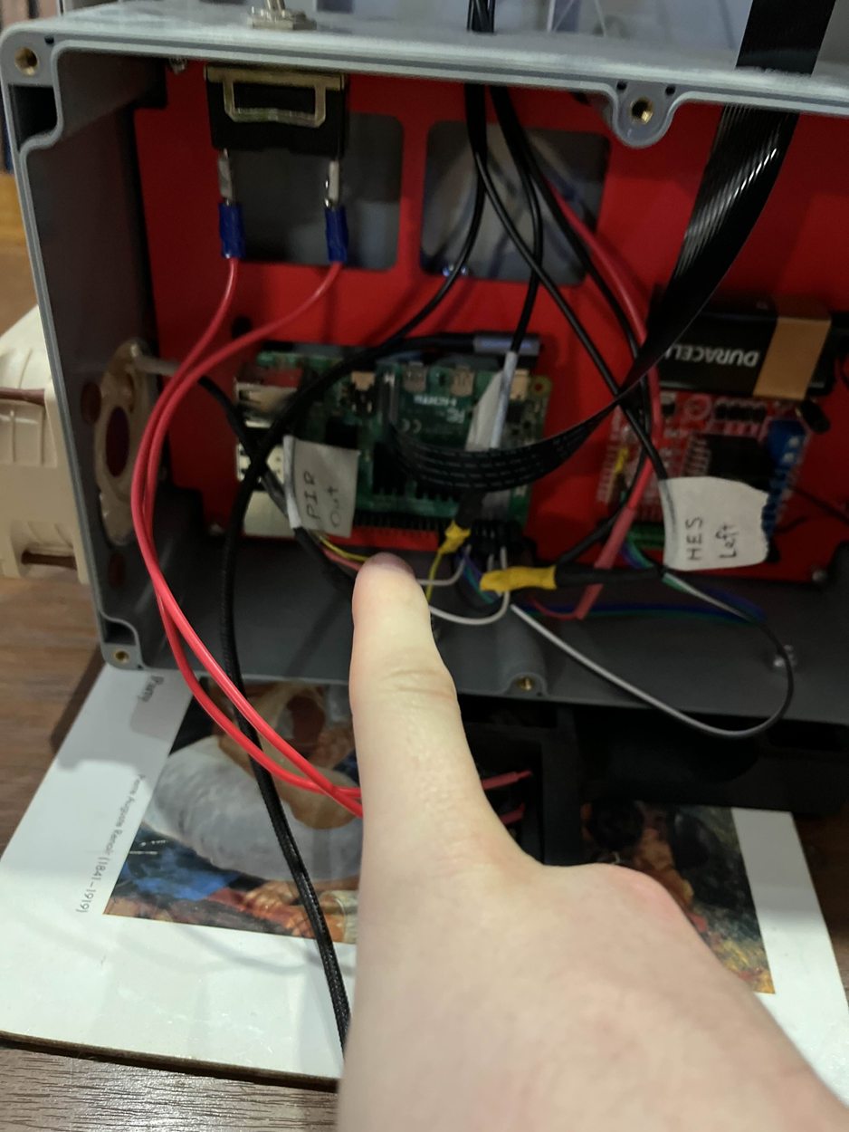

**Figure 1.** Layout of first prototype

The first step was to remove the Raspberry Pi and replace it with the Jetson Nano. This was a relatively straightforward process, involving the removal of the Pi and its standoff screws and replacing them with the Jetson Nano and its companion standoff screws. Following the wiring schematic from the previous documentation resulted in the successful installation of the Jetson Nano. Refer to the software section for the setup and implementation of this step.

After setup, the system did not work. Despite correct wiring and programming, the test cases created for the door to open and close did not result in any action. Upon further investigation, it was found that the current motor board was either faulty or incompatible with the Nano. Testing with a multimeter showed that the Jetson Nano was outputting the required voltage via the GPIO pins, but when everything was wired up, the motor board itself was outputting voltage, which should not have been happening.

After more research, it was discovered that the issue likely stemmed from the PWM (pulse width modulation) required by the specific motor board, which was interfering with the operation of the Nano. The Jetson Nano struggles with PWM, whereas the Raspberry Pi handles it without issue. This could explain why the system worked with the Pi but not with the Nano.

### Software

There were clearly some difficulties and issues encountered when attempting to run the inference of the models even under the Jetson Nano. When trying to run the first prototype’s code, the whole Jetson Nano would freeze and would require us to either wait a bit of time to wait for it to unfreeze or restart the Jetson Nano entirely. While some of the rest of the code worked, the issue mainly was around the detection process.

Through research, we later found out that Pytorch models tend to be a bit intensive for the Jetson Nano to handle. The way we can get around this is to use something known as TensorRT, which is used for inference optimization provided by NVIDIA. We use this to convert the Pytorch models to the optimised “engine” models for the Jetson Nano to use.

On top of that, we wanted to restructure the code into the finite-state-machine, so that way the code is far easier to manage and read when needing to add more functionalities to the SmartGate system

## Current Prototype

### System Overview

The SmartGate Project is an integrated system designed to protect vulnerable species by selectively controlling access through a physical gate using artificial intelligence. The system comprises several key components working in harmony to achieve this goal:

1. **AI Detection System:**  
   At the core of the SmartGate is a YOLOv5-based object detection model running on an NVIDIA Jetson Nano. This powerful yet compact single-board computer processes real-time video feeds from a high-resolution camera mounted near the gate. The pre-trained YOLOv5 model is capable of identifying various animal species making split-second decisions on whether to open or close the gate.
2. **Gate Mechanism:**  
   The physical gate is controlled by a L298N electric motor board, which receives commands from the Jetson Nano based on the AI's decision-making process. The gate's position is monitored by two Hall effect sensors - one for the fully open position and another for the fully closed position. This feedback ensures precise control and status reporting.
3. **Power Management:**  
   To optimise power consumption, especially crucial in remote deployments, the system incorporates a PIR sensor. This sensor activates the main detection system only when movement is detected near the gate, significantly extending battery life during periods of inactivity.
4. **Web Server and Remote Access:**  
   The Jetson Nano also hosts a web server, providing a user-friendly interface for remote monitoring and control. This allows authorised personnel to access the system from any device with a web browser, be it a desktop computer or a mobile phone. The web interface offers features such as manual gate control, system status monitoring and live camera feed viewing.
5. **Network Connectivity:**  
   The system is equipped with both Ethernet and Wi-Fi capabilities via the Jetson Nano, ensuring flexible deployment options. In remote areas, it can be configured with a cellular modem for internet connectivity, enabling real-time monitoring and control from anywhere in the world.

The SmartGate system operates in a continuous loop:

1. The motion (PIR) sensor detects approaching animals and activates the main system.
2. The camera captures video of the approaching animal.
3. The YOLOv5 model on the Jetson Nano processes the video feed in real-time.
4. Based on the AI's classification, the system decides whether to open or keep the gate closed.
5. The motor actuates the gate accordingly.
6. The Hall effect sensors confirm the gate's position.
7. All actions and detections can be viewed through the web interface.

### Software Overview

The SmartGate Project's software is built on a multi-threaded Python application, designed to efficiently manage AI-based animal detection, gate control, and user interaction. The architecture is divided into two main threads, each handling distinct responsibilities while communicating seamlessly to ensure smooth operation of the entire system.

#### Main Thread: AI Detection and Gate Control

The main thread implements a finite state machine (FSM) that manages the core functionality of the SmartGate system. This thread is responsible for:

**a) AI-based Animal Detection:**

* Utilises the pre-trained YOLOv5 model to process video frames from the camera.
* Performs real-time object detection and classification of animals.

**b) Gate Control Logic:**

* Implements a state machine with states such as 'IDLE', 'DETECT', 'DOOR_OPEN' and 'DOOR_CLOSE'.
* Transitions between states based on AI detection results and system events.

**c) Configuration Management:**

* Reads and interprets a JSON configuration file that specifies rules to determine which animals trigger when the gate opens or closes.
* Allows for dynamic updates to the system behaviour without code changes.

**d) Sensor Integration:**

* Monitors inputs from the PIR sensor to activate the detection system (from camera).
* Reads Hall effect sensors to confirm gate position (open/closed).

**e) Motor Control:**

* Sends commands to the gate motor based on the current state and detection results.

#### Web Server Thread: User Interface and System Monitoring

The web server thread runs concurrently with the main thread, providing a user-friendly interface for remote access and control. Key features include

**a) Video Streaming:**

* Captures video from the camera and streams it to connected clients in real-time.

**b) Gate Control Interface:**

* Provides buttons for manual gate control (open/close).
* Implements methods to interact with the main thread for gate operations.

**c) System Monitoring:**

* Displays real-time status of the gate (open, closed, or in motion).
* Shows current AI detection results and confidence levels.
* Monitors and reports Jetson Nano hardware statistics (CPU usage, disk usage, memory utilisation).

**d) Configuration Interface:**

* Allows users to view and modify the JSON configuration file for animal detection rules.

Inter-thread Communication: The two threads communicate using thread-safe mechanisms:

* The main thread updates shared data structures with current system status and detection results.
* The web server thread reads from these structures to display real-time information of the gate status.
* User commands from the web interface are passed to the main thread via a command queue.

**Future Security Considerations:**

* All web communications are encrypted using HTTPS.
* User authentication is required for accessing the web interface.

**Scalability and Extensibility:** The modular design of the software architecture allows for easy addition of new features or integration with other systems. For example:

* Additional AI models could be incorporated for more diverse animal detection.
* Defined ruleset for the user to define how the gate should behave on certain stimuli
* The system could be expanded to be integrated with other smart farm equipment.

For further information regarding the software, please refer to Appendix 5.2.

#### Software Development

We created a systemd service that is enabled to start on boot. If any error or exceptions are thrown, the systemd service will attempt to restart the program. We created a script, [systemd_service_setup.sh](https://github.com/TheOpenSI/SmartGate/blob/main/setup/systemd_service_setup.sh), to set the service up automatically. We have also added a [setup script](https://github.com/TheOpenSI/SmartGate/blob/main/setup/setup_requirements.sh) and a [Dockerfile](https://github.com/TheOpenSI/SmartGate/blob/main/Dockerfile) to assist in setting up any requirements for the project itself.

We did manage to get the Marsupial models running on the Jetson Nano on some sample videos and images obtained from the internet. The Marsupial models are provided as Pytorch models (.pt files), and we had to convert them to TensorRT models (.engine) models. See Figure 2 below on the detection results.

**Figure 2**. Marsupial Detection models under Jetson Nano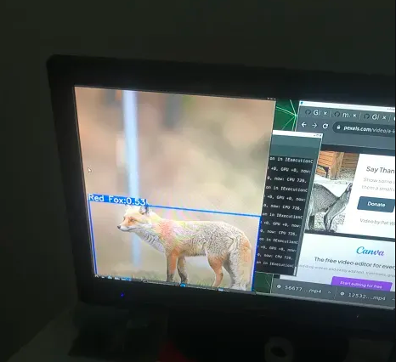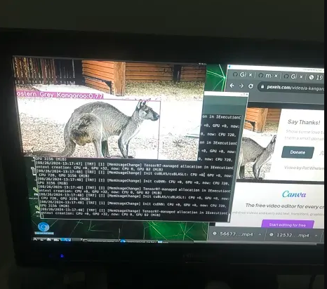

### Hardware Overview

The SmartGate Project incorporates several key hardware components to create a fully functional and efficient system:

1. **Jetson Nano developer board 4GB:**  
   The NVIDIA Jetson Nano is a compact yet powerful single-board computer designed for AI and machine learning applications utilising GPU acceleration. The board comes with 4GB of LPDDR4 memory and supports storage via a microSD card. It can process multiple neural networks in parallel, making it ideal for applications such as image classification, object detection and segmentation.
2. **L298-N motor control board:**  
   An electric motor board is employed to physically open and close the gate. This motor is carefully selected to provide sufficient torque for smooth operation while maintaining energy efficiency. The motor is directly controlled by the Jetson Nano based on the AI's decision-making process.
3. **Passive-infrared sensor:**  
   To conserve power and extend the system's operational life, a PIR sensor is integrated onto the SmartGate. This sensor activates the camera for the main detection system only when movement is detected in the vicinity of the gate. This approach significantly reduces power consumption during periods of inactivity, making the system more sustainable for long-term deployment in remote areas.
4. **Hall effect sensors:**  
   Two Hall effect sensors are installed at strategic points to detect the gate's position. One sensor indicates when the gate is fully closed, while the other confirms when it's completely open. These sensors provide crucial feedback to the control system, ensuring accurate gate positioning and enabling status reporting to the user interface. Magnets are placed on the moving gate itself to create open and close points
5. **Camera:**  
   A high-resolution camera is mounted near the gate to capture images or video streams of approaching animals. This camera feeds directly into the Jetson Nano for real-time processing by the AI model.

#### Hardware Development

##### The Motorboard

Most of the technical aspects were undertaken in the UC Capstone lab. Ask Carlos for process to access or if outside of UC make sure your organisation has the tools and resources required or outsource production to third parties.

As mentioned in 3.1 the PWM on the motor board is controlled via the EN A-B pins. The voltage applied to these pins dictates how fast the motor turns. By jumping the 5V and ENB cables, as shown in Figure 2 below, the goal was to disable these pins and constantly set the ENB function of the board to HIGH, meaning the motor would turn at its highest speed continuously. However, this approach did not work.

We also attempted to power the board’s logic via the battery, rather than through the Jetson Nano. Unfortunately, this also failed.

Several different pin configurations were attempted, and a temporary solution was eventually found.

During the different wiring attempts, we discovered that grounding one of the IN pins while connecting the other to the Jetson Nano caused the motor to move, albeit slightly shorting the circuit. This led to the realisation that the motor driver board was outputting voltage rather than receiving it, an issue we still haven't been able to fully explain. However, connecting the other IN pin to ground completed the circuit and moved the motor. Grounding it would complete the circuit and move the motor.

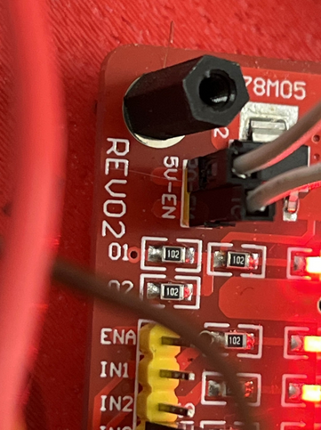

**Figure 3**. Jumper cable to 5V and EN pins

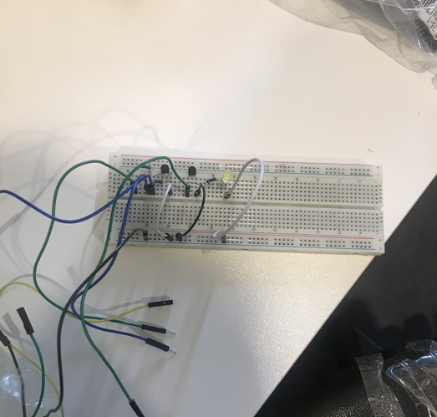

**Figure 4**. The Grounding Solution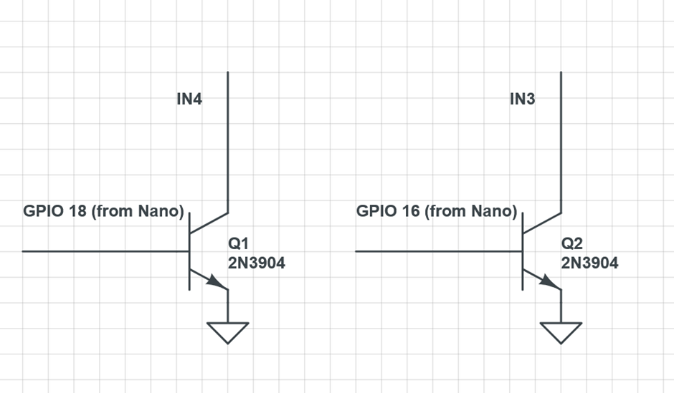

**Figure 5**. Circuit diagram of solution

In Figures 3 & 4, a circuit is shown that essentially directs either IN1 or IN2 to ground depending on input from the Jetson Nano.

This circuit worked by directing the required pin to ground, completing the circuit. Although this was not an ideal or permanent solution, it temporarily allowed progress on the software side, enabling further programming and development to continue. However it was clear that a new and different motor board would be required.

Two parts were ordered to potentially solve the issue: a new motor board, the L298N, and the PCA9685 16-Channel PWM Servo Driver. These parts were chosen based on research, as the PWM problem with the Jetson Nano is a common issue. The PCA9685 was selected because it is a frequently recommended solution, acting as an interface between the Jetson Nano and the motor driver to handle PWM without the Jetson needing to. The L298N was chosen for its affordability, reliability, and the extensive documentation and support available online.

Purchase Links:

* Servo Driver (PCA9685): [Purchase Link](https://lonelybinary.com/products/driver-pca9685?variant=39314845991069&currency=AUD&utm_medium=product_sync&utm_source=google&utm_content=sag_organic&utm_campaign=sag_organic&gad_source=1&gbraid=0AAAAABe-hwrEfC2541cbzP3FAPg0TQcu5&gclid=EAIaIQobChMIqP-hjY-AiAMVE9AWBR0fvicVEAQYASABEgI8d_D_BwE)
* Motor Driver (L298N): [Purchase Link](https://www.makerstore.com.au/product/elec-l298n-motor-drv/?srsltid=AfmBOopGbpxLpOBvEuq30zXc0ifo1DA4sK8si-2X0e4ybI6KhbA8MLfq)

When the parts arrived, the L298N worked perfectly, and the servo driver was not required. The old motor board was retired. The new motor board required slightly different wiring, as it had a different layout from the previous board. A custom wire was soldered, connecting the ground from the battery to both the board and the Jetson Nano, creating a shared ground that is showcased later in figure(?) And the wiring diagram.

##### Improving the Prototype

Four main items were purchased with our budget for the unit:

* Arducam – An improved camera native to the Jetson Nano, solving the issue encountered in the previous prototype.  
   [Purchase Link](https://core-electronics.com.au/arducam-high-quality-camera-123mp-123-inch-imx477-hq-camera-module.html)
* SD Card – Provided storage for the Jetson Nano and allowed for backups of the current flash. Can be purchased anywhere, make sure you have a device capable of read/write to SD
* Solar Panels – A concern was that the battery could run out if the prototype were ever deployed, and these solar panels addressed that issue.  
   [Purchase Link](https://www.amazon.com.au/JumpsPower-Foldable-Roadtrip-Portable-Cell-Phone/dp/B0D73RJSGX/ref=mp_s_a_1_1_sspa?dib=eyJ2IjoiMSJ9.8mE5QKmZ3PVVBMdMlTTOJ74wK-ib5TRenDCpH-5W5gg8YFbAgeLwqRg1OplFmJtqkxIxSGVtfOZ0lhSewNVFMSTvtG5XDgQigY46iCDyZElaa58mVObvpto7FRMP6RMurFtpI4i4fTEVDn4aTToI-m-417ZQObnhOwNQoPQ9xPd1LJAjO7b_d8NQ6KDXSHrPQxiIuiNlqra4Cjg4ij7keA.fueg23xGOZj0qIFumNeG5UwBXIfSmiW866SRsHX0V_E&dib_tag=se&keywords=usb+solar+panel&qid=1723451864&sr=8-1-spons&sp_csd=d2lkZ2V0TmFtZT1zcF9waG9uZV9zZWFyY2hfYXRm&psc=1)
* Edimax WiFi Adapter – Provided WiFi capabilities for the Jetson Nano, enabling SSH access to the device.  
   [Purchase Link](https://www.amazon.com.au/Edimax-EW-7611ULB-Wi-Fi-Supports-Bluetooth/dp/B01KVZB3A4?th=1)

When purchasing parts for the project one of the main things to consider was modularity and how it would affect future prototypes. For the software setup of these components, please refer to the software documentation. These items resolved all three concerns listed in the previous documentation, as well as unforeseen issues such as enabling SSH access. Most components were simply plug-and-play from a hardware perspective, but the camera posed a unique challenge.

**Figure 6**. Camera cables side by side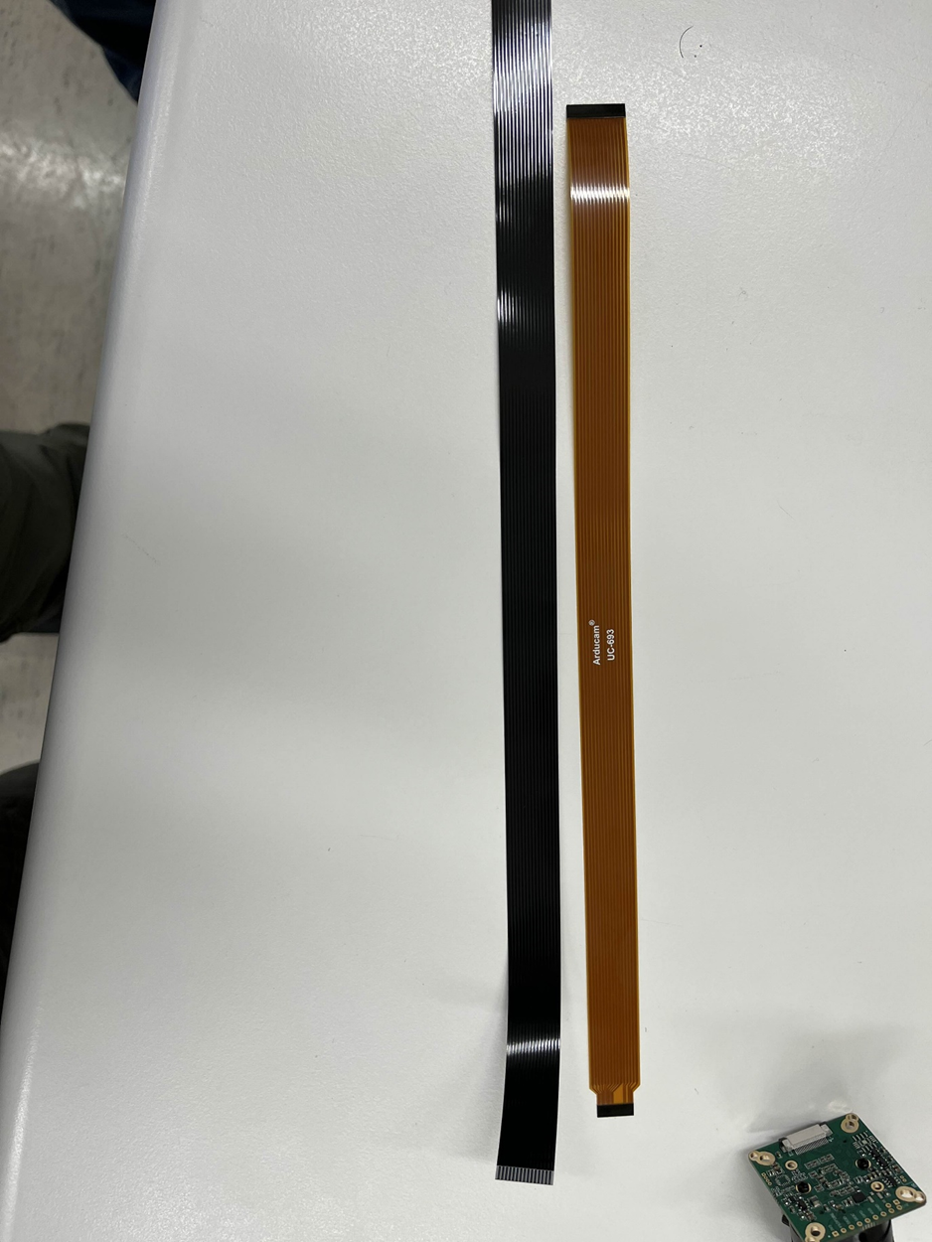

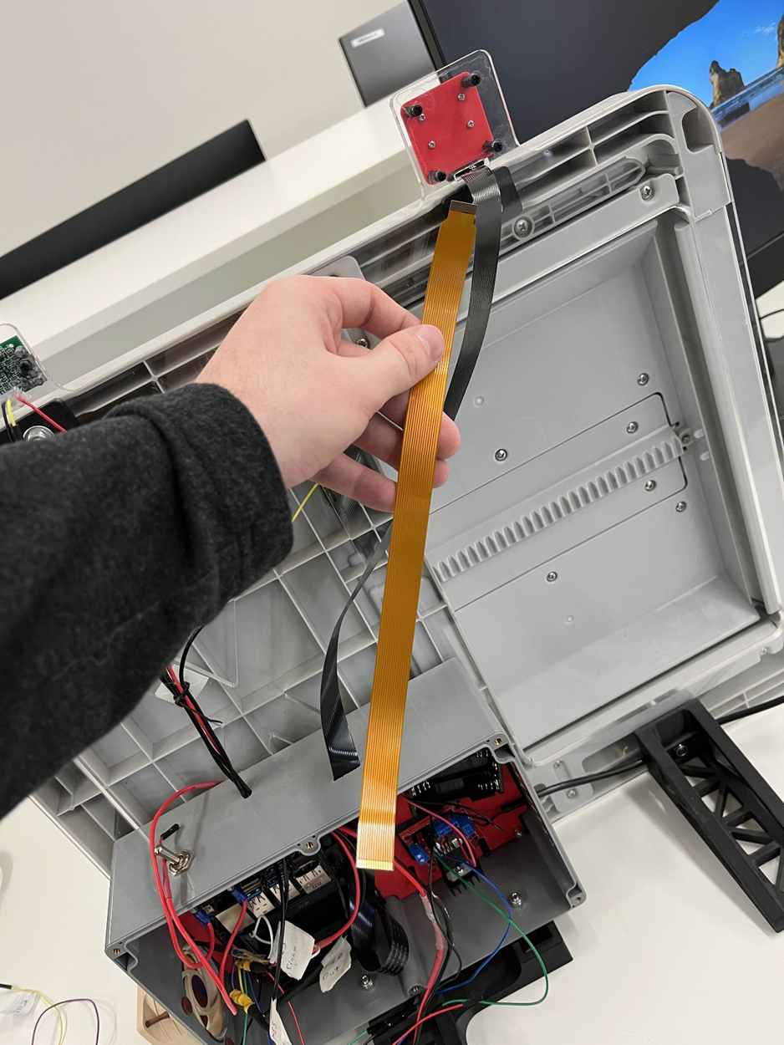

**Figure 7**. Camera cable length

The new and improved camera came with a new type of cable—one that was both too short and the wrong shape. This double dilemma made it impossible to plug the new camera in with the current mounting. Upon researching, it was found that this type of cable does not come in longer lengths, and even the longest available option was still too short. Additionally, the cable had a different connector, meaning the previous cable could not be reused. As shown in the figure, the ends of the two cables differ significantly.

We found a potential solution in the CSI/DSI Cable Joiner.

Purchase Link: [CSI/DSI Cable Joiner](https://core-electronics.com.au/adafruit-csi-or-dsi-cable-extender-thingy-for-raspberry-pi.html)

This part was ordered, and while waiting for it to arrive, experimentation with two cameras was conducted. It was found that, due to the Linux nature of the Jetson Nano, it was incompatible to have two different cameras on the board at the same time because of conflicting drivers and related issues. This problem could be solved by purchasing an additional camera of the same make and model, but that is beyond the scope of our budget.

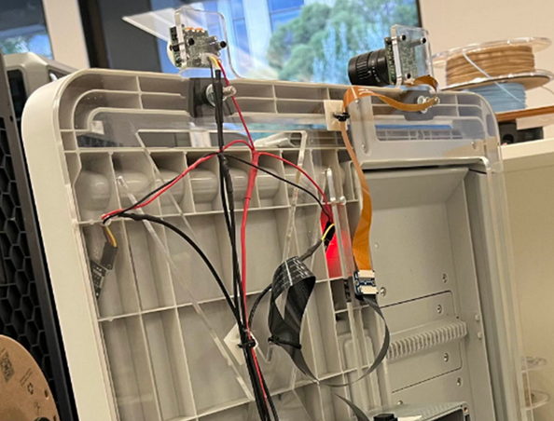

**Figure 8**. Current iteration of camera setup

As shown in the figure above, the CSI/DSI extender is affixed to the frame using a Velcro strip, and the excess DSI cable is secured with a loose zip tie. We opted for this solution to maintain modularity and allow for future improvements, rather than glueing it in place as previous teams did with the Hall effect sensors. I believe this is a much better and more flexible option. In the event of a second Arducam which is in the todo list another one of these would probably need to be purchased.

**Solar Panels:** The solar panels were purchased with the intent of deploying the prototype in the field, should it reach that stage. The main qualities considered were that the panels had to be lightweight, weather-resistant, and compatible with the battery pack currently in use. These criteria led to the choice of a product originally designed for camping, as it can be easily deployed on a fence with minimal setup. Since the panels are intended for charging phones and battery packs, we are confident they won’t overload the system's battery pack.

**Improving the Circuits:** The installation of the power switch was relatively straightforward, following the official documentation from Waveshare, specifically Point 15 at [Jetson Nano Dev Kit Documentation](https://www.waveshare.com/wiki/JETSON-NANO-DEV-KIT).

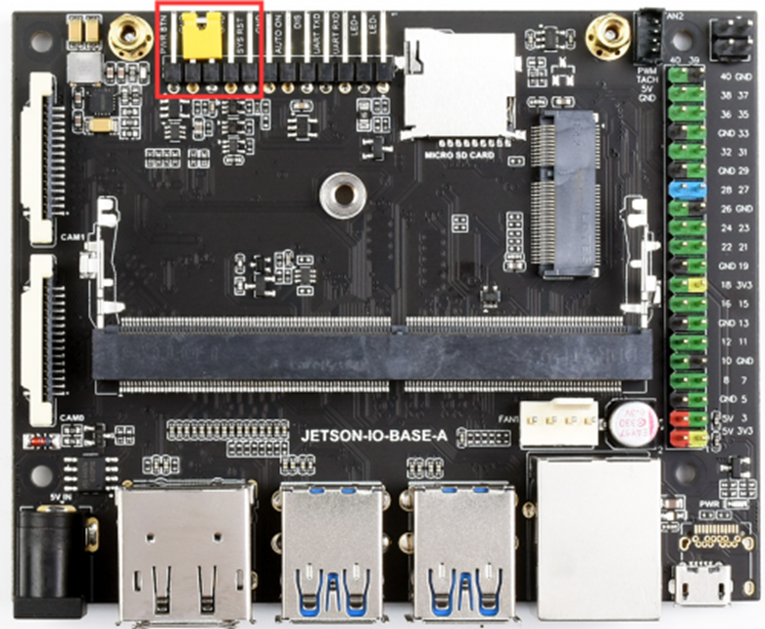

**Figure 9**. A Jetson Nano with heat sink removed

While removing the heat sink is not necessary, the Jetson Nano itself needs to be removed, as the relevant connectors are inaccessible without taking it off its standoff screws.

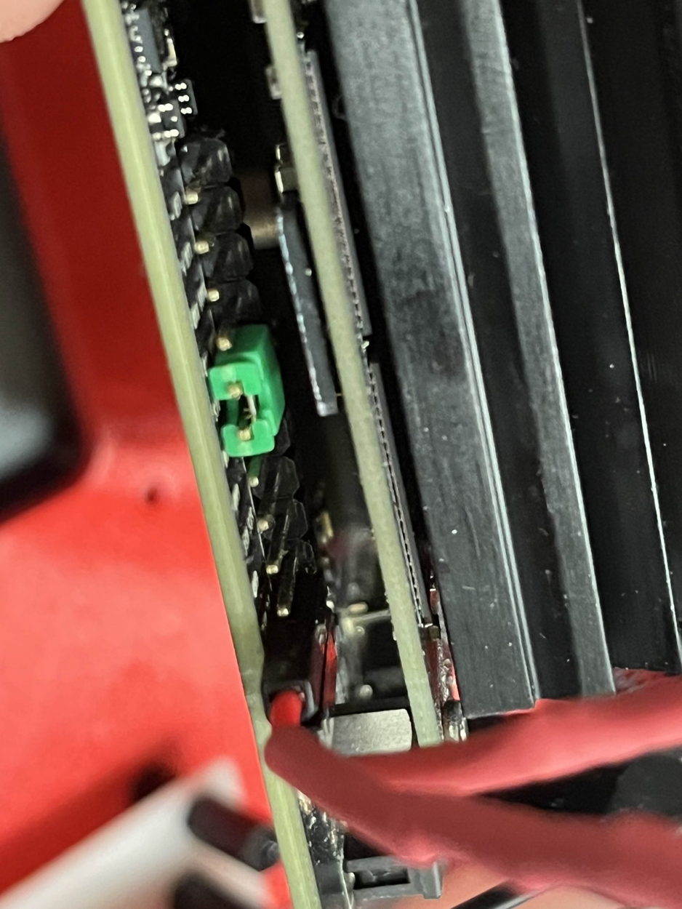

**Figure 10**. Our Jetson Nano with jumper and power switch wired in

It is important to note that this power switch does not turn off all components. It functions similarly to a PC power switch, shutting down the OS and system logic but leaving auxiliary components, such as LEDs and the fan, powered constantly. Because of this, a second power switch was hardwired into the battery pack to avoid unnecessary battery drain and potential part deterioration due to constantly powered auxiliaries.

**Figure 11**. Soldering of the power switch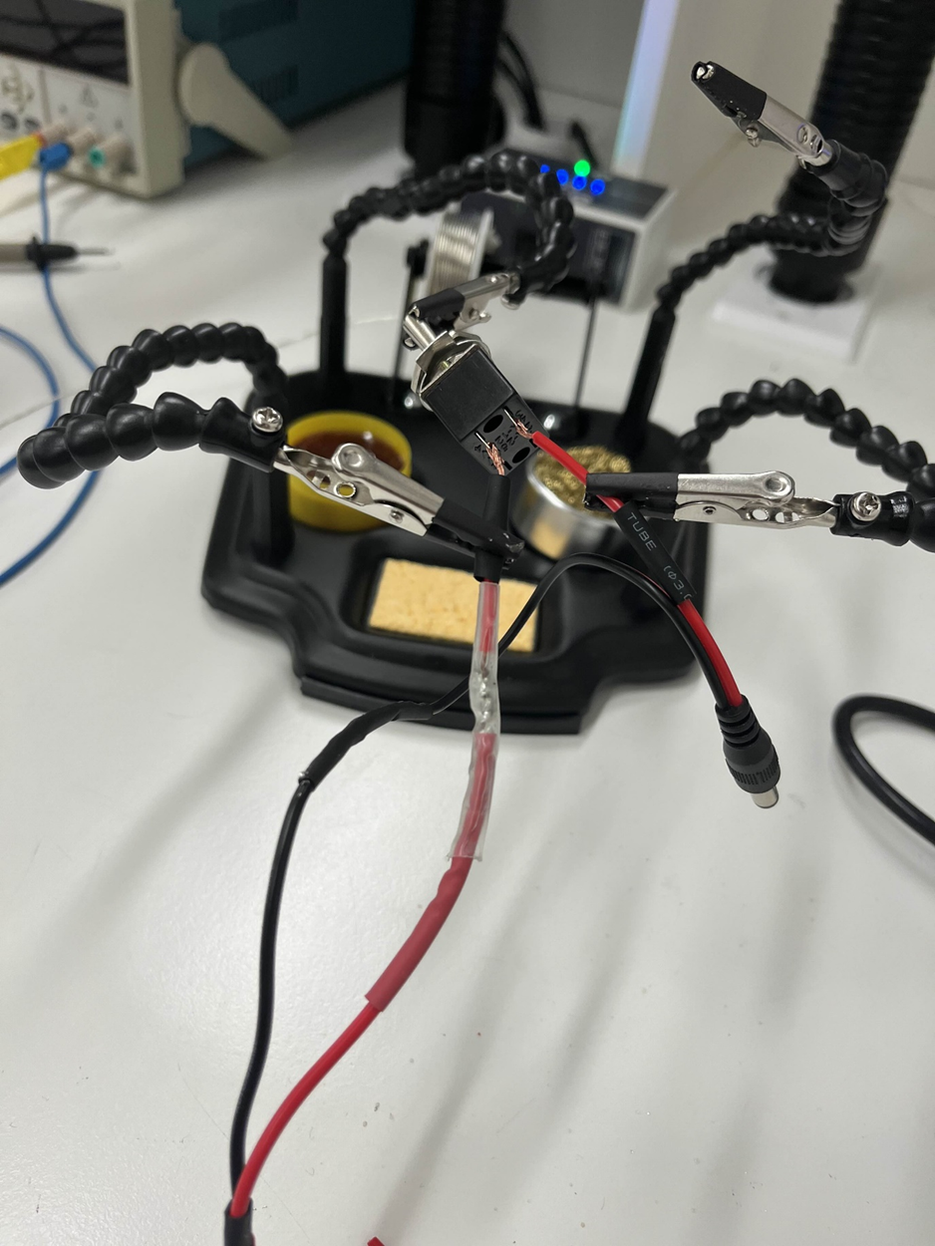

During this process, the power source for the system was also upgraded. The 9V battery was replaced with 6x AA batteries, which provide better longevity and a more efficient system. The batteries were given their own dedicated power switch, which was hardwired into the circuit. Modifications to the control box were required to accommodate the new switches. This was achieved using a large drill bit and extreme care. Important Note: Do not modify the control box while the circuits are connected or powered, as this could cause irreparable damage.

**Figure 12**. Old battery and motor board setup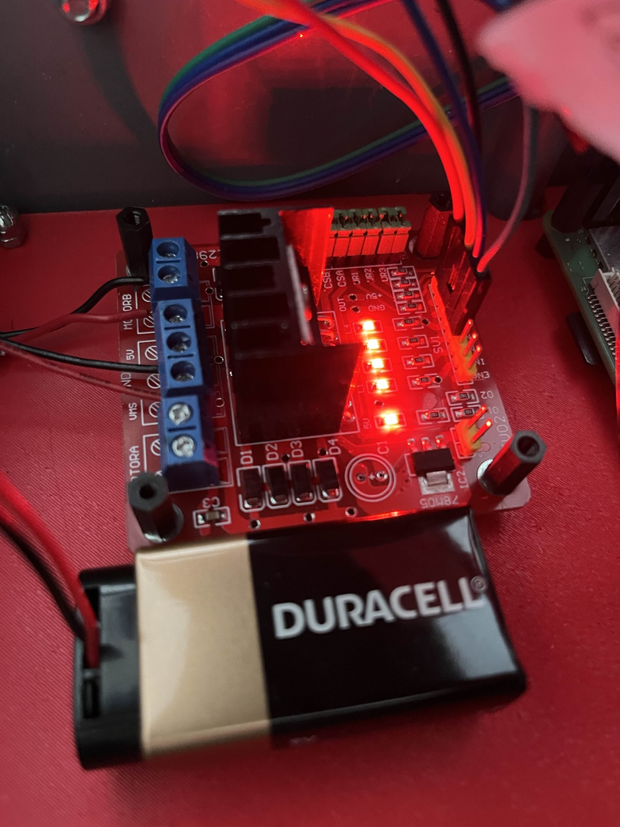

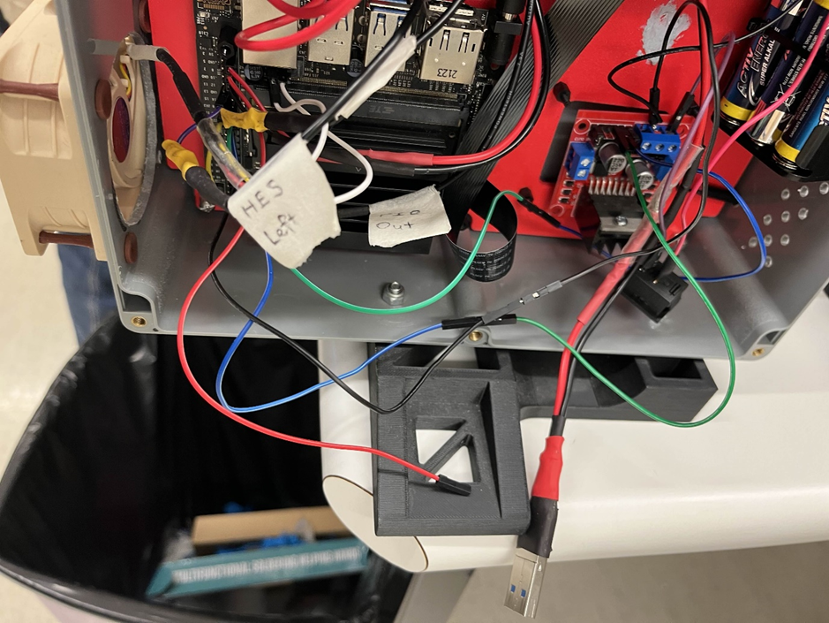

**Figure 13**. Battery zip tied and motor board on single screw

The new batteries added significant weight, which was temporarily managed by zip-tying the battery pack to the coolant holes on the control box. However, this was a temporary fix. Additionally, the motor board had been mounted using only a single standoff screw, which was inadequate. A solution was needed to address both issues simultaneously. We decided to 3D-print custom parts, as this was a cheap, customizable, and efficient way to resolve the problems.

The 3D printed mounting bracket needed to take into account the mounting holes of the previous motorboard, the mounting holes of the new motorboard, as well as provide support for the battery pack. This brack went through 3 iterations. The first iteration was essentially 2 rectangles pieced together, one being large enough for the motorboard, and the other for the battery pack. The one for the battery pack also had 2 L-shaped protrusions on it for the battery pack to rest on. Underneath the battery pack rectangle were small supports of the same length as the offsets used, so as to make it so that the bracket won’t snap when pushed up against.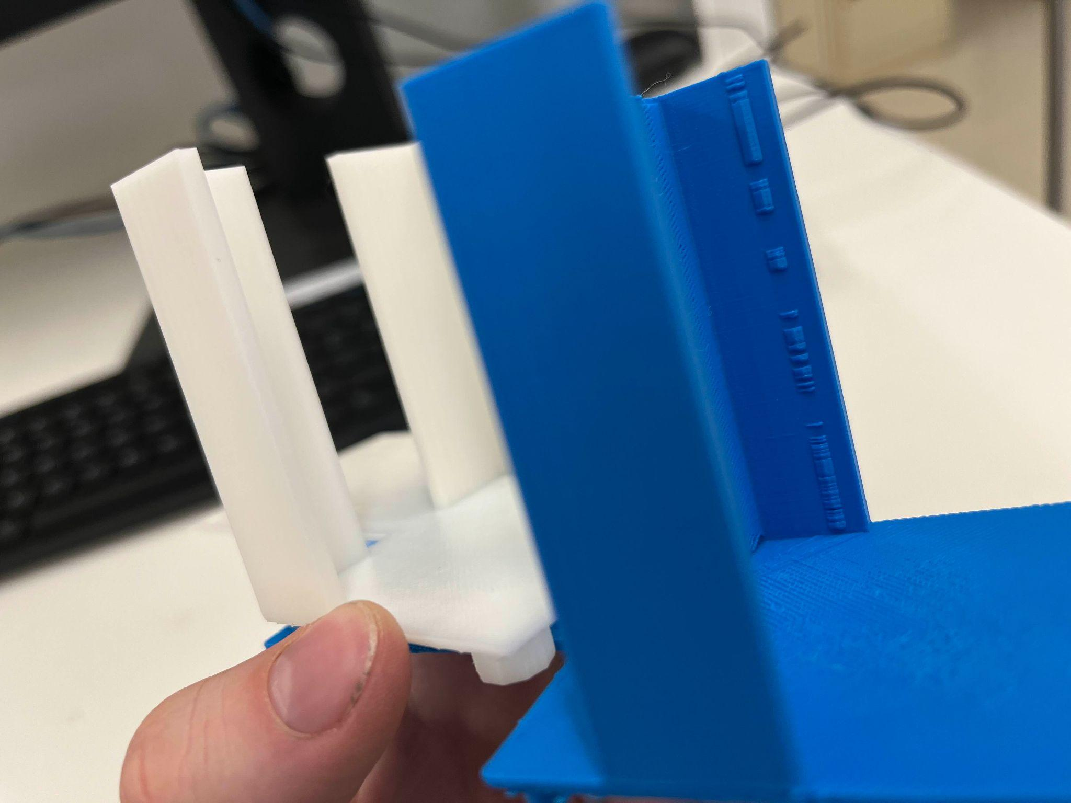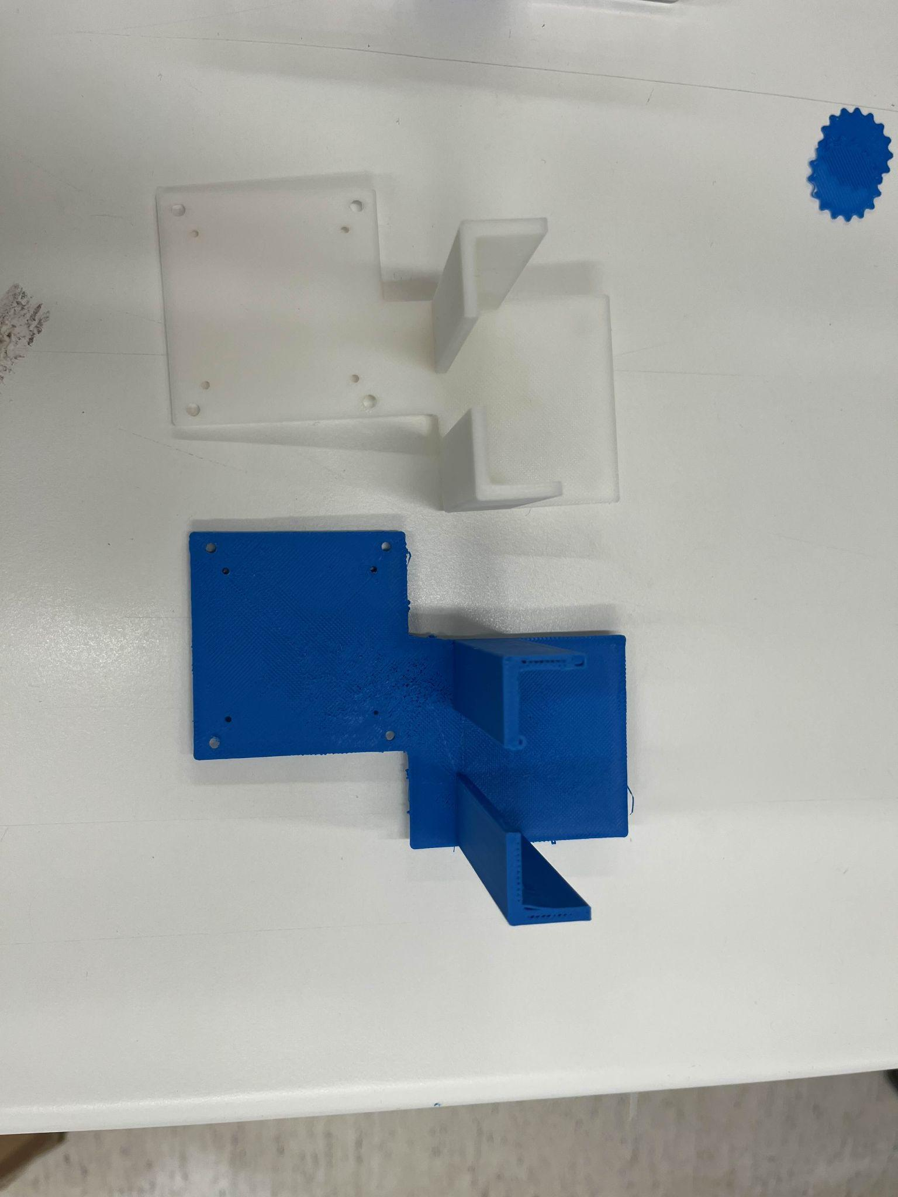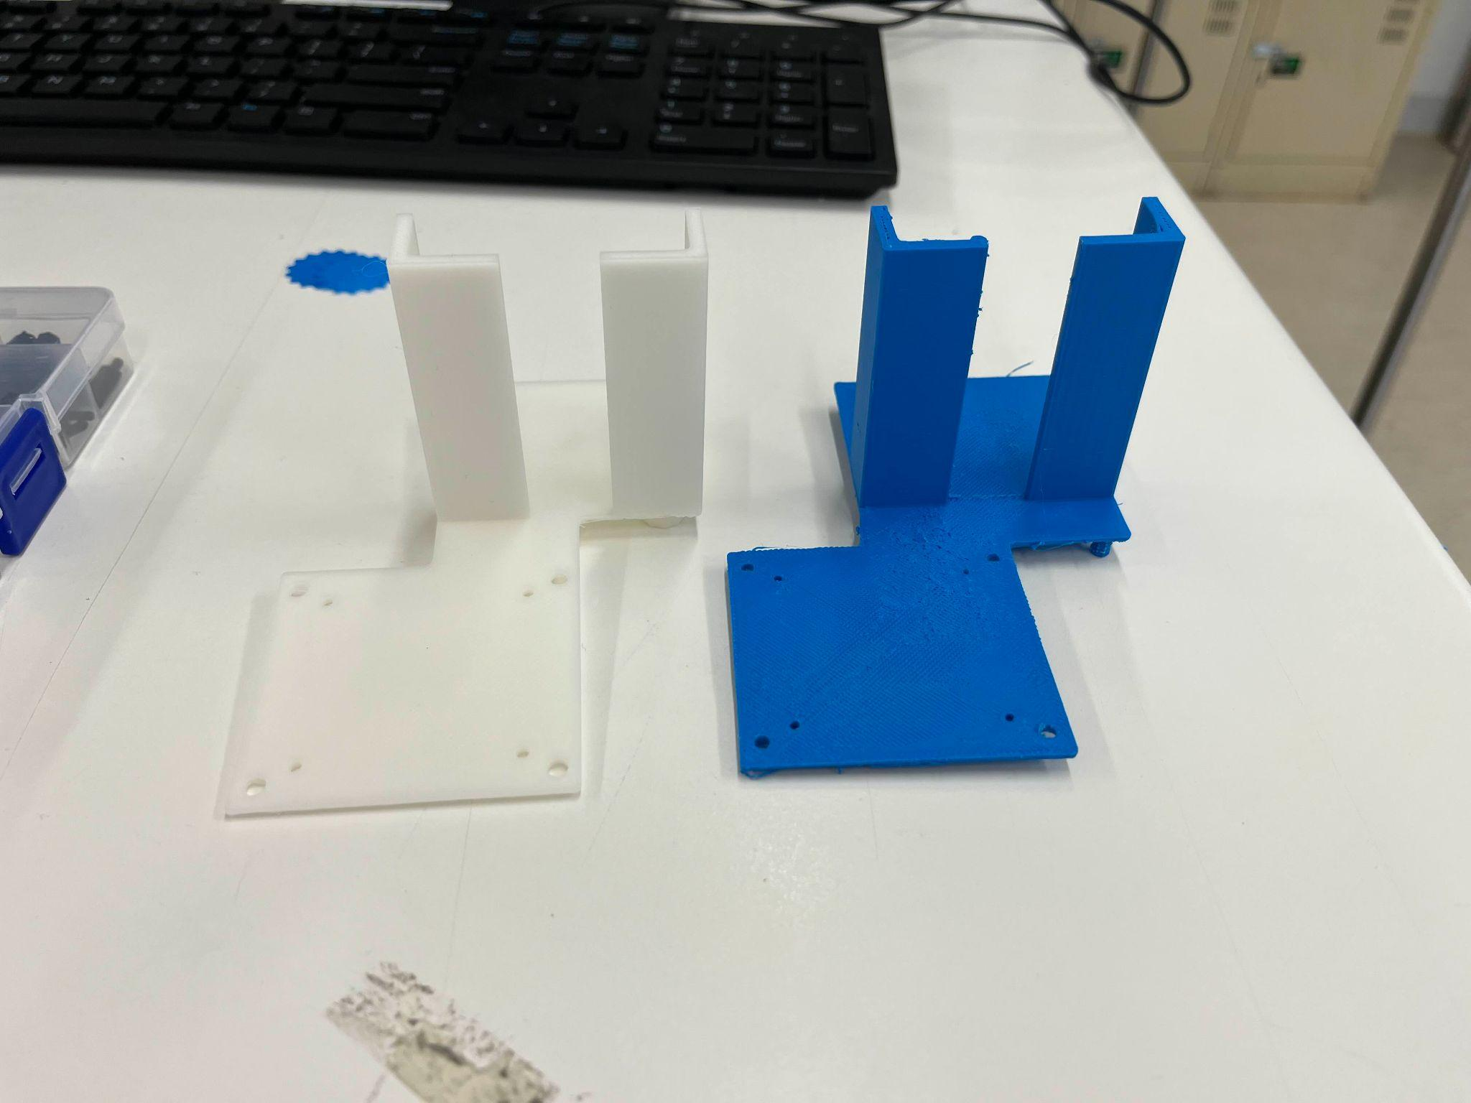

The issue with this iteration was that one of the L-shaped protrusions interfered with the wiring on the top of the motorboard. This issue was discovered before printing and so changes were made resulting in the 2nd iteration. The second iteration added material between the 2 rectangles, ensuring that there is enough space for the wires to sit and was then printed. When this iteration finished printing, however, the supports underneath the battery section had broken when attempting to remove the support material from the printing. As such, that iteration could not be used. The final and current iteration solved that by increasing the size of the supports underneath, ensuring that they have enough structural support to stay on when removing support material from the printing. Additionally, we removed some excess material that we thought was unnecessary. Furthermore, we realised the printer we had used for iteration 2 was not very stable, and as such, created a lot of imperfections. This was a discovery we made after the printing of iteration 3 which had come out a lot more smooth, with there being minimal amounts of random protrusions on the surfaces of the bracket. Figures x below show iteration 2 and iteration 3 and their differences.



**Figure 14**. Different view of iteration 2 (blue) and iteration 3 (white) of the mounting bracket

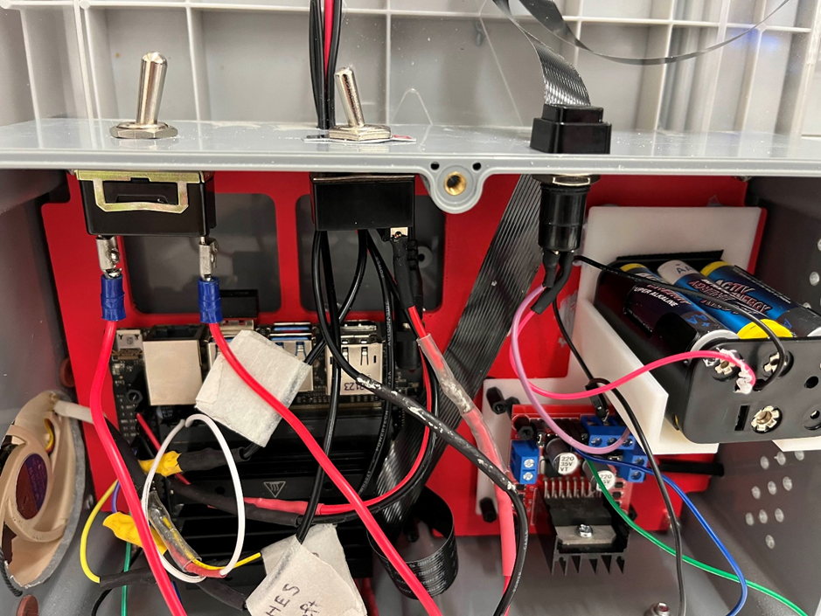

**Figure 15**. New switch setup and battery and motor board installed in control box

Due to the new switches and their operation, a specific order for startup and shutdown is recommended. These instructions are attached to the side of the control box, but in case they are removed, they are also provided in a supplementary file. This order is necessary because, if powered on or off in the wrong sequence, the motors may spin independently due to a current imbalance. This could cause the motors to continue spinning even when they reach their maximum extension, potentially turning them into small generators and sending electricity back into the system, which could damage components.

# Further Work

## Future Prototypes & improvements

### Reconfigure the Layout of the Jetson Nano and Control Box

Currently, it is nearly impossible to work on the Jetson Nano safely with its existing configuration (see Figure 14). The ports don’t have enough space inside the control box to properly access. The current workaround is to remove the Jetson from its standoff and let it rest gently, supported by the wires and a brace from below. This is far from ideal and needs to be addressed in the next phase.

**Figure 16**. Current working conditions of the jetson nano when plugged in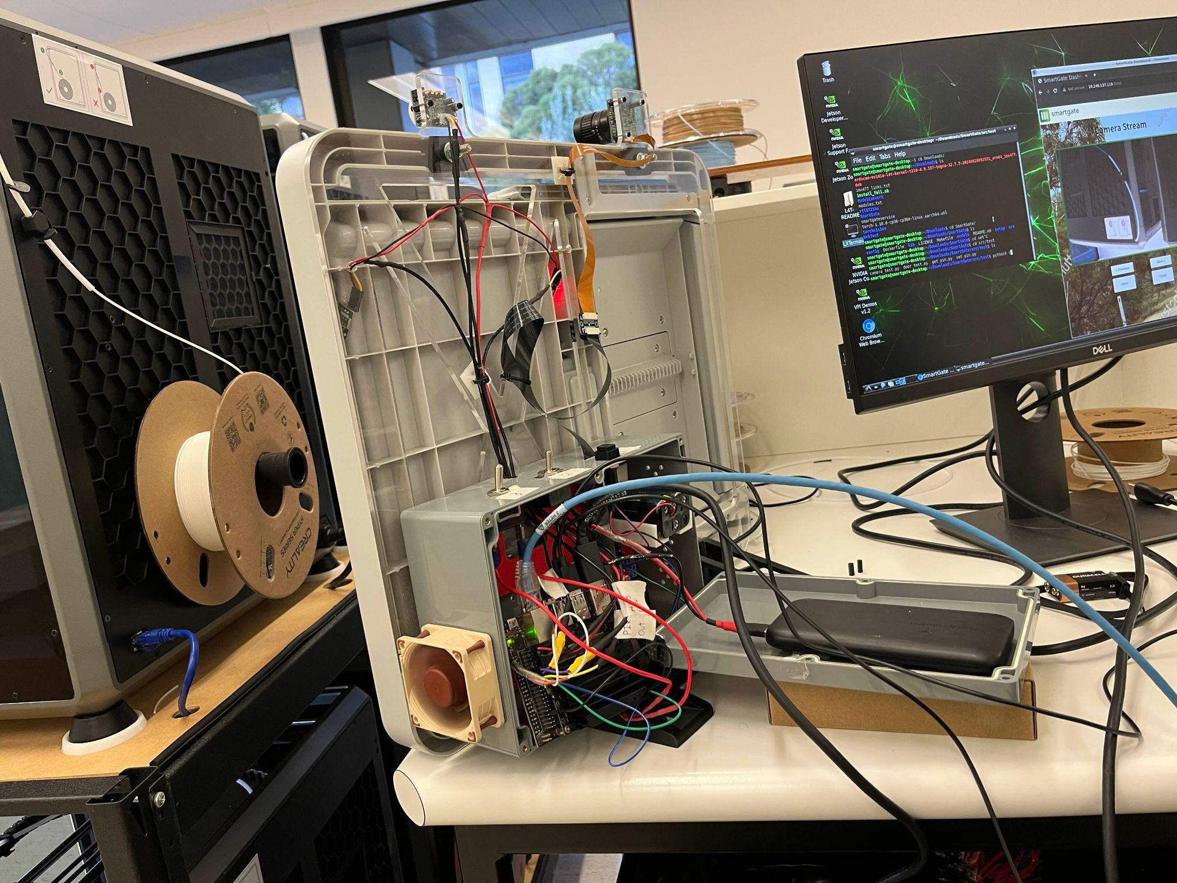

### Either Reprint with Screw Holes or Add Manually to the 3D Bracket

Currently, the 3D-printed bracket is supported by screws from the motor board, but the weight of the battery causes it to slowly bend forward, sagging under the load. This issue is temporarily mitigated using Blu Tack, but this is only a short-term solution. Adding screw holes through the supports behind the battery could provide secure anchoring to the baseplate, which would prevent sagging and ensure a more stable setup.

### Enlarge the Control Box

This ties into the reconfiguration of the Jetson Nano layout. We believe a larger control box would solve many issues, such as cramped wiring and inaccessible ports on the Nano. Additionally, we want to relocate the battery into the control box instead of having it affixed to the lid. Currently, extra care is needed when removing the lid to access components. Moving the battery inside the control box would make maintenance much easier. Also, note that the wires are currently a bit too short, and the lid needs additional support underneath to prevent stress on the wires and to avoid having the lid and battery free-floating, which will put strain on the delicate power switch wiring and potentially break it.

### Upgrade the Jetson Nano and potentially motor

Currently, the system functions well, but there is a significant delay due to the capabilities of the Jetson Nano. This delay may also be compounded by the motor that came with the Omlet chicken door. Upgrading the motor is essential, as it could provide much faster speeds for the door's operation. However, a more powerful motor may require an upgraded power source, depending on the size and power demands of the new motor. Upgrading the computer component (the Nano) would also provide much greater control over the system and reduce delay times. Unfortunately, these upgrades are constrained by budget limitations and are beyond the current scope of this project.

### New door

While this is well beyond the scope and budget of the current iteration and phase of the project, it was theorised that, at higher speeds, the way the door closes could potentially harm the animal by acting like a guillotine. When the prototype eventually scales to higher production, it is recommended that a door powered by hydraulics be used. This door would be affixed to the top of the doorway and would open up and out, remaining suspended at a 90-degree angle. When closing, this design would gently guide the animal into the safe enclosure, minimising any risk of harm.

### Fix hallway effect sensor problem

Occasionally the gate can find itself in a strange position where the magnets on the door are unreadable by the hallway effect sensors when a signal is sent to close or open it at approx 20-30% open this causes the door to just freeze until a new input is detected finding a solution to this would be good

### Multiple cameras

It is highly recommended that the final product use multiple cameras, as the gate will need detection for both sides to allow animals through both ways. Additionally, more cameras allow different angles, allowing for better detection.

### Improved AI model

The current AI detection model, while trained, can sometimes be slow or inaccurate. This can make it hard for the gate to recognise it needs to close in time and by the time it reacts, it may be too slow. For the purposes of the current prototype, the current model is fine but future implementations may need improvements.

### Web development

Current website is primitive, with basic styling, functions and stock images. Future development will need multi-camera and/or multi-gate compatibility, as well as live statistics. Multi-camera and/or multi-gate compatibility is a recommended feature because in addition to the multi-camera functionality that we recommend, users will likely want multiple gates for their purposes and having them all accessible via a single website may prove useful. The live statistics will prove use for researchers and/or organisations that wish to deploy the gates for nature preservation purposes. Both of these functions have been added in a primitive manner and will require further work to be ready for the final product.

### More Powerful Computer

A more powerful computer may be required for the final product. With features such as real time data updates, multiple cameras and an improved AI, the computing power required may increase to a level that the Jetson Nano can no longer handle. It is for this reason we recommend an upgraded computer chip for future development.

### Web server improvements

The current web server implementation currently uses Python’s [http.server](https://docs.python.org/3/library/http.server.html) module. While it is functional and operational, further security measures and precautions could be taken into account while further developing the web server.

### Battery (motor board) circuit improvement

Currently to replace the batteries is a delicate process as its still relatively short wires, not a super difficult task but not ideal, to improve this I would solder a plug onto the wire just a typical male to female plug this would allow the battery holder to be removed completely rather than have to hold it close as you replace the batteries. I believe this improvement would also benefit the modularity of the system

## Recommended Skill Sets

Throughout the development of this prototype, we have identified key skills required for future development attempts. These skills include key skills used during this development cycle, as well as skills our team did not possess which we believe will be integral if not necessary for future development.

1. Linux - A deep understanding of Linux systems proved to be integral for the development of this project, as it is the main medium used in developing the software and controlling the Jetson Nano.
2. Python - The primary programming language used for the scripts for controlling the gate is Python. These main scripts are for opening and closing the door based on the AI detection, this is a highly recommended skill to have for troubleshooting purposes.
3. Mechanical design and Manufacturing - An important skill to have when designing future prototypes. Any changes to the physical gate, whether there be changes to the control box, the implementation of a new gate mechanism, or just changing the current design to be more resistant to weathering or animals, will require knowledge in this field.
4. Wireless Communications - Setting up wireless communications in future prototypes will require extensive knowledge in wireless communications to ensure that the gate can be accessed remotely. The current prototype uses WiFi and will be recommended to have an understanding in WiFi communications
5. Web Development - This skill is needed for the front-end web interface for remotely controlling and monitoring the SmartGate system
6. Remote Power Systems - Current prototype relies on batteries and a small amount of solar energy. The final product will need to consider extended periods of deployment, and thus will need a form of consistent power to ensure it is constantly operational.
7. Circuit knowledge including both electrical and GPIO programming - This skill is highly recommended for reading wiring diagrams, ensuring that future wiring is done correctly.
8. Soldering - Recommended to ensure the longevity of the components as well as safety of users by ensuring that the components are soldered and electrically connected in a safe and professional manner. Also allows custom circuits out of wires with ease
9. Experience with Machine Learning Models - Highly recommended skill for the SmartGate project as it is the core functionality of the project. Knowing how to utilise ML models is needed, but training models is not a requirement.
10. Git - The project is currently hosted under GitHub and skills for version control, especially Git, would be highly recommended to keep the project maintained and open-source

# Appendix

## SmartGate Overview Document

[SmartGate Overview Document](https://github.com/TheOpenSI/SmartGate/tree/main/docs)

## Software in-depth Rundown

The [repository](https://github.com/TheOpenSI/SmartGate/tree/main) is free and open for anyone to view and contribute to on GitHub, and licensed under GPLv3. The [README](https://github.com/TheOpenSI/SmartGate/blob/main/README.md) contains a basic overview on setting up the requirements and initial setup for the SmartGate software. Additionally, it provides links to relevant documentation such as [setting up the Jetpack SDK](https://developer.nvidia.com/embedded/learn/get-started-jetson-nano-devkit) as well as [converting a .pt file to .engine file](https://youtu.be/ErWC3nBuV6k?t=988).

### Project file structure

The repository follows the following file structure and is recommended that it is maintained consistently.

* Folders are this colour
* Files are this colour
* Hidden Files are this colour

*Each listing is a clickable hyperlink and will jump to in-depth subheading of the file or folder.*

├───.gitignore

├───Dockerfile

├───LICENSE

├───Makefile

├───README.md

├───config

├───docs

├───lib

├───models

│ └───classes

├───setup

│ └───drivers

└───src

├───main

├───test

└───web

#### .gitignore

Ensure any build-related files and folders are specified in this file to ensure they are not tracked by Git. For more info, read the Git documentation on .gitignore [here](https://git-scm.com/docs/gitignore).

#### Dockerfile

The Dockerfile contains all the necessary dependencies to build the Docker container. The selected base image utilised is the [*nvcr.io/nvidia/l4t-pytorch:r32.7.1-pth1.10-py3*](http://nvcr.io/nvidia/l4t-pytorch:r32.7.1-pth1.10-py3) image which includes CUDA and Python. It’s important to note that the Docker container is optional to use when setting up the SmartGate project.

#### LICENSE

This project is licensed under the GNU General Public License v3.0 (GPLv3). The GPLv3 is a strong copyleft licence that requires anyone who distributes the code or a derivative work to make the source available under the same terms. More info can be viewed [here](https://www.gnu.org/licenses/gpl-3.0.en.html).

#### Makefile

The Makefile simply includes build targets to run or build the Docker image specified from the Dockerfile. This can be used by simply running make build in the terminal to build the container or make run to run a shell instance of the built container (ensure this is executed on the same directory as the Makefile).

#### README.md

The README currently should detail a comprehensive overview of the SmartGate project such as features, requirements, setup, usage, contacts and details on contribution. The README should be in Markdown format.

#### config/

The config folder is mainly used for configuration of the program itself. It currently contains a singular JSON file, ‘[config.json](https://github.com/TheOpenSI/SmartGate/blob/main/config/config.json)’, to configure the SmartGate software’s loaded model, ruleset behaviour and server configuration. More in depth is explained of the configuration JSON file [in the README](https://github.com/TheOpenSI/SmartGate/tree/main?tab=readme-ov-file#setup).

#### docs/

Any documentation of the SmartGate project is found in this folder.

#### lib/

The lib folder contains shared libraries that are required for the SmartGate software. As of now, it should contain ‘libmyplugins.so’, a library required for TensorRT to extend its capabilities to support operations required by YOLO models that are not built into TensorRT by default.

#### models/

The models folder contains the TensorRT Engine (.engine) models for the detection. These files are made to be more optimised to be able to be run under the Jetson Nano as opposed to a Pytorch (.pt) model. If a Pytorch file is needed to be converted to a TensorRT Engine file, a guide is available on [YouTube](https://www.youtube.com/watch?v=ErWC3nBuV6k) or on [GitHub](https://github.com/mailrocketsystems/JetsonYolov5).

##### classes/

The classes folder simply contains a list of classes respective to the detection model from the models/ folder. It will need to be in the following format: index: class (click [here](https://github.com/TheOpenSI/SmartGate/tree/main/models/classes) to look at some examples).

#### setup/

The setup folder contains any setup scripts or files to install and set up any dependencies locally on the Jetson Nano. Right now it should have [setup_requirements.sh](https://github.com/TheOpenSI/SmartGate/blob/main/setup/setup_requirements.sh) to install required dependencies (with requirements.txt) and [systemd_service_setup.sh](https://github.com/TheOpenSI/SmartGate/blob/main/setup/systemd_service_setup.sh) to set up the systemd service to run on boot.

##### drivers/

The drivers folder includes scripts for installing required drivers for specific devices. Driver installation is optional and should only be performed if the corresponding hardware is present. Currently, it contains the Arducam IMX477 setup script, which configures the drivers for the Arducam IMX477 camera module on the Jetson Nano.

#### src/

The src folder contains the core source code of the project, organised into three main subdirectories: main/, test/ and web/.

##### main/

The main folder houses the primary application logic and core functionality.

The core of this system is a state machine that controls the gate operations based on sensor inputs and object detection results. The entry should be in [live_detection.py](https://github.com/TheOpenSI/SmartGate/blob/main/src/main/live_detection.py).

##### 

**Figure 17**. SmartGate FSM diagram

###### State Machine Overview

1. **IDLE State**:

* Default state of the system
* Monitors PIR sensor for movement
* Checks Hall Effect sensors for door position
* Transitions to DETECT state if movement is detected

1. **DETECT State**:

* Activates when movement is detected
* Captures images using the camera
* Performs object detection using YOLOv5 with TensorRT
* Compiles a list of detected objects
* Transitions to DECISION state after detection

1. **DECISION State**:

* Analyses the list of detected objects
* Uses a [RulesetDecider](https://github.com/TheOpenSI/SmartGate/blob/main/src/main/ruleset_decider.py) object to determine the next action
* Transitions to either DOOR_OPEN, DOOR_CLOSE, or back to IDLE based on the decision

1. **DOOR_OPEN State**:

* Initiates the door opening mechanism
* Monitors the door's position using Hall Effect sensors
* Stops the motor when the door is fully open
* Returns to IDLE state once the operation is complete

1. **DOOR_CLOSE State**:

* Initiates the door closing mechanism
* Continuously checks the door's position
* Stops the motor when the door is fully closed
* Returns to IDLE state after completion

1. **DELAY State**:

* This state is not in use through the state machine as it was used for debugging purposes

###### State Machine Operation

* The system continuously loops through these states
* Each iteration checks for external commands (obtained from web server) that may override the current state
* Sensor inputs (PIR and Hall Effect) influence state transitions
* The object detection results in the DETECT state inform the DECISION state
* Safety checks are implemented in each state to prevent overruns or conflicts

###### Web Server Thread

In addition to the main state machine, the system runs a separate web server thread:

* Provides an HTTP interface for remote interaction with the system
* Allows external commands to be sent to the main state machine
* Offers status updates about the current state and door position
* Operates independently but communicates with the main thread through shared data structures
* Can stream the camera feed for remote monitoring

This dual-threaded architecture allows for a responsive local control system via the state machine, while also providing remote access and control capabilities through the web server.

**Important note:** Is that avahi-daemon is already configured on the Jetson Nano, meaning a .local domain with the hostname is already set up (smartgate-desktop.local).

##### test/

This directory contains scripts for testing the system.  
These tests are designed to verify various components of the SmartGate system under the Jetson Nano platform:

The camera functionality is tested using a script ([camera_test.py](https://github.com/TheOpenSI/SmartGate/blob/main/src/test/camera_test.py)) that initialises a video capture stream via OpenCV and GStreamer. It displays the camera feed in real-time, allowing visual confirmation of the camera's operation and image quality. This test ensures that the system can properly access and process video input.

The door mechanism is evaluated through a separate test ([door_test.py](https://github.com/TheOpenSI/SmartGate/blob/main/src/test/door_test.py)) that simulates opening and closing operations. The test repeatedly triggers the door opening sequence, providing a way to observe the motor's responsiveness and the accuracy of the control signals.

Two additional scripts focus on the GPIO operations. One ([get_pin.py](https://github.com/TheOpenSI/SmartGate/blob/main/src/test/get_pin.py)) allows reading the state of any specified GPIO pin, continuously monitoring and reporting its status (HIGH or LOW). This test is valuable for verifying sensor inputs, such as Hall effect sensors or the motor drivers. The other script ([set_pin.py](https://github.com/TheOpenSI/SmartGate/blob/main/src/test/set_pin.py)) enables setting the state of any GPIO pin, which is useful for testing output controls like the motor drivers.

Developers can verify the functionality of individual parts of the system before integrating them into the main state machine-driven application.

##### web/

This is where the code for our front end web server page source code resides.  
The HTML and CSS files ([index.html](https://github.com/TheOpenSI/SmartGate/blob/main/src/web/index.html)  + [index.css](https://github.com/TheOpenSI/SmartGate/blob/main/src/web/index.css)) sets up the structure of the dashboard, including a navigation bar with a logo, a video stream display area, and control buttons.

The front-end code creates an interactive interface for monitoring and controlling the SmartGate system, allowing users to view camera feeds, operate the gate, and check system status in real-time.

The JavaScript file ([index.js](https://github.com/TheOpenSI/SmartGate/blob/main/src/web/index.js)) implements the interactive functionality of the dashboard:

1. Camera Controls: It provides buttons to cycle through multiple camera streams, although currently only one camera is set up.
2. Door Controls: "Open" and "Close" buttons send POST requests to the server to control the gate's position.
3. Status Retrieval: A "Get Status" button fetches and displays various system statistics from the Jetson Nano, including CPU temperature, usage, memory and disk usage, and door state.

## Wire Map

Screenshot of wire map please see complete file for higher resolution 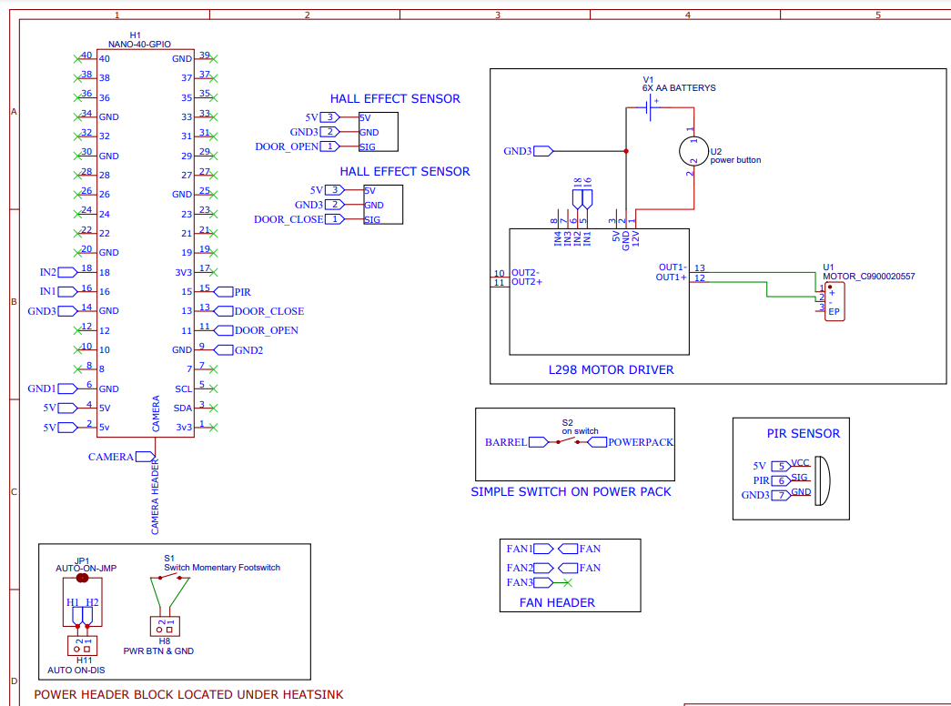

## Helpful links for the nano

<https://www.waveshare.com/wiki/JETSON-NANO-DEV-KIT-MANUAL#GPIO>

<https://developer.nvidia.com/embedded/learn/jetson-nano-2gb-devkit-user-guide>

<https://forums.developer.nvidia.com/t/power-switch/79647/3>

<https://www.waveshare.com/wiki/JETSON-NANO-DEV-KIT>

## Notes for use

**Note:** When using and testing the gate with the Australian animal model, we found that due to poor training, the system can misidentify many miscellaneous objects as certain animals. For example, it detected a 3D printing reel as a fallow deer and a person as a lyrebird. To mitigate this, we conduct tests as often as possible with the system facing a blank wall or a background with minimal objects. Let the system run for a few minutes and observe what it detects in the background. If it is detecting background objects as the animals it's supposed to recognize, it can significantly throw off the testing process.

To address this, we created several cardboard cutouts with handles to hold the test images. This helps avoid having hands or fingers in the frame, as they can often be detected as animals. It's important to note that this issue seems to be exclusive to the Australian animal dataset. The standard YOLOv5 model appears to be trained much better and does not exhibit this problem. See the figures below for some examples.

## Bill of materials

| **Item** | **Description** | **Performance Criteria** | **Cost** |
| --- | --- | --- | --- |
| NVIDIA Jetson Nano Developer Kit | System computer to house and run the object recognition model, control I/O |  | $432.56 |
| Omlet automatic chicken coop door | Door to act as system output |  | $279.99 |
| Raspberry Pi HQ Camera Board | Camera module to capture images and video for analysis |  | $85.00 |
| 6mm wide-angle lens | Lens for camera module |  | $42.00 |
| Camera cable (610mm) | Cable for connecting camera to Raspberry Pi |  | $5.95 |
| USB battery pack | Battery to supply system without requiring mains power |  | $59.95 |
| 32 GB micro SDHC card | To house operating system for Jetson Nano |  | $22.95 |
| SPST Toggle Switch | For turning on Jetson Nano |  | $7.95 |
| Passive IR Sensor | For detecting movement to trigger camera |  | $9.95 |
| Control box | Housing for computer + battery |  | $42.95 |
| Jumper leads | For connecting electrical components |  | $14.95 |
| Heat shrink | For insulating electrical connections |  | $19.95 |
| WH3040 Red wire | For connecting electrical components |  | $1.40 |
| WH3041 Black wire | For connecting electrical components |  | $1.40 |
| Acrylic sheet | For mounting electrical components and providing stability |  | $50.00 |
| 9V Battery clip | To connect 9V battery to motor controller |  | $2.90 |
| USB 3.0 type A plug | To connect to battery |  | $7.90 |
| Fused cigarette lighter plug to 2.1mm DC plug | To connect to Jetson Nano |  | $8.95 |
| Noctua 5V Fan | For cooling the Raspberry Pi |  | $59.35 |
| M2.5 Standoff kit | For attaching various components |  | $42.65 |
| Velcro strips | For mounting components within control box |  | $7.90 |
| LN298 motor controller board | For controlling the door motor |  | $14.95 |
| Hall effect sensors | For detecting when the door is open/closed |  | $9.90 |
| Epoxy Glue | For attaching the hall effect sensors and magnets to the door |  | $8.40 |
| Ferrite Magnets | For signaling when the door is open/closed |  | $4.95 |

Total: $1244.80